6'-6"

2'-9"

Earth/Soil Filling around pipe
1'-9"

Platform 6.5'x5.5'
5'-6"
2'-0"

4'' Drain Pipe 30' length

Safe Disposal or Soakage Pit

X X

4¹₂"

Step#3
3'-0"
1'-0"

18'

3'-6"

Ramp for PWDs 3.5' wide, 18' long
Step#2

Step#1

Stairs

Parapet Wall
3"
1'-6"

G.L
1'-0"

4¹₂"
Plaster (1:4) inner & outer

9"
1'-6"

PCC (1:2:4)
6"
1'-0" 3" 3"
Lean (1:4:8)

Compacted Soil
5'-9"

9"

Cross Sectional View at XX
1.5'' dia UPVC Pipe 1/2'' Shrouding
3'' dia UPVC Casing Pipe

Cloth around filter

3"

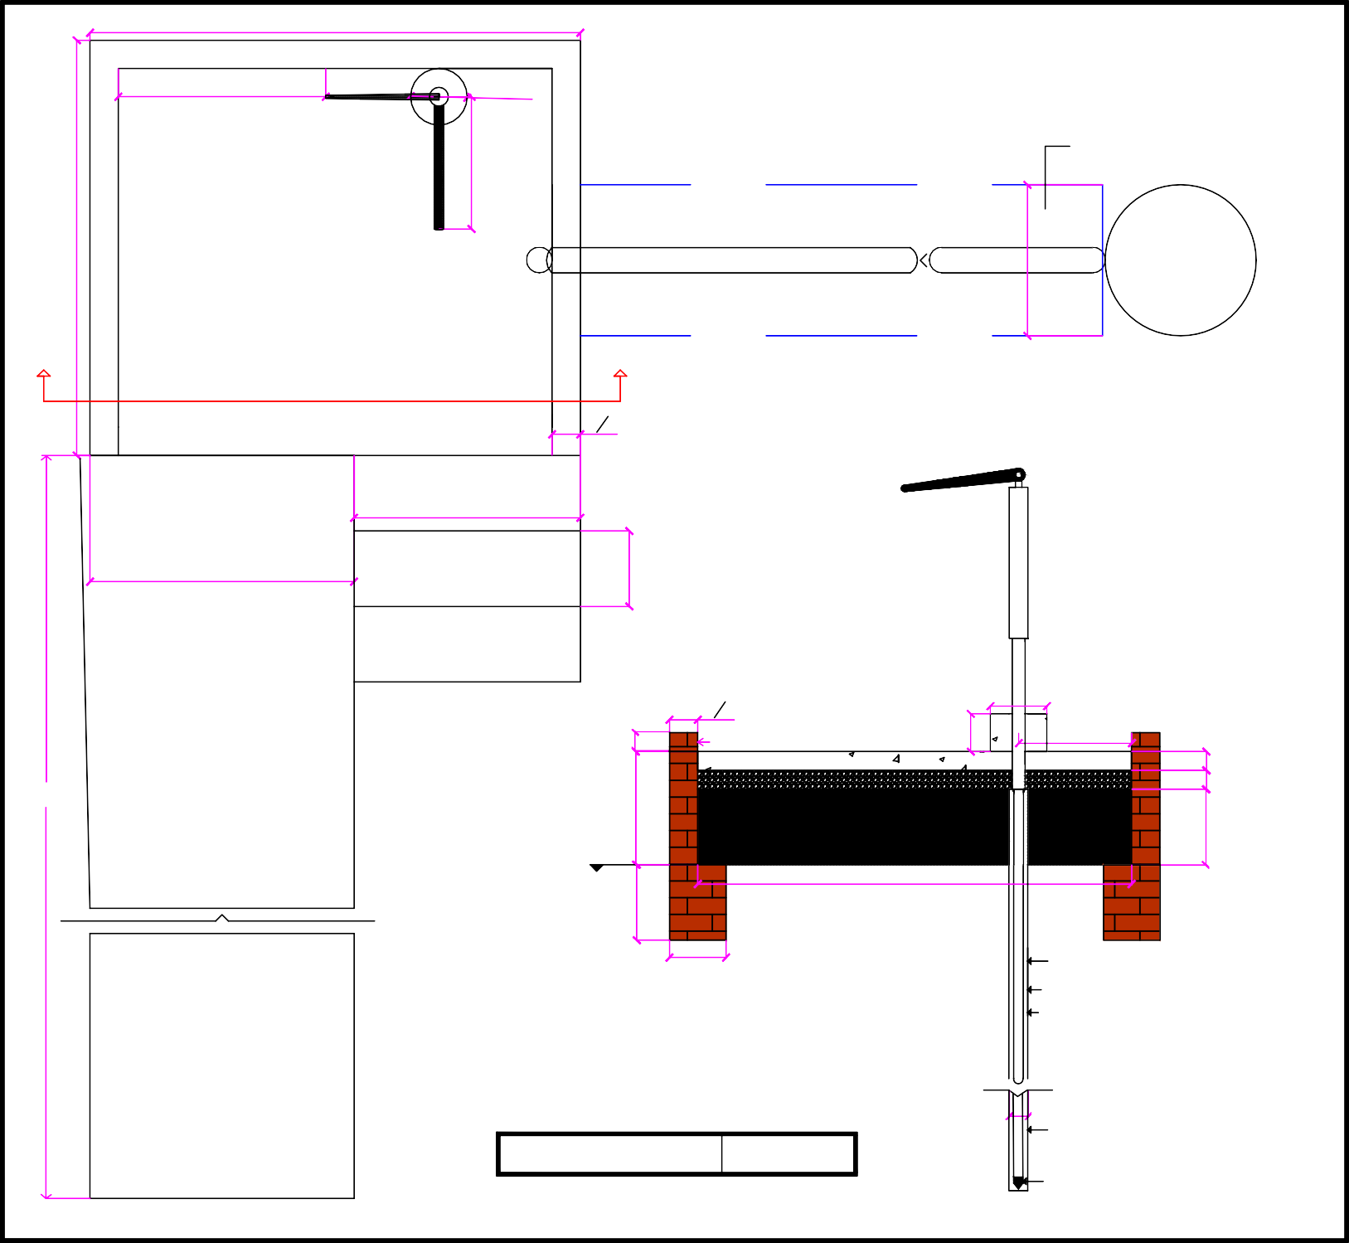
Shallow Hand Pump
LAAN+

Wooden Plug Average Bore Depth 70'

